Heartful Life Coaching
Preparation Questionnaire
This questionnaire is designed to help you get the most out of the
Heartful Life Coaching Programme. It will help me get to know you more fully so I can best support you. It will also help you clarify what you want out of the programme. As you respond to the questions – let your mind and emotions run free. This isn’t a test – there are no right or wrong answers. These questions are stepping stones to a deeper relationship with yourself, your dreams and your potential and anything that might be holding you back from that.

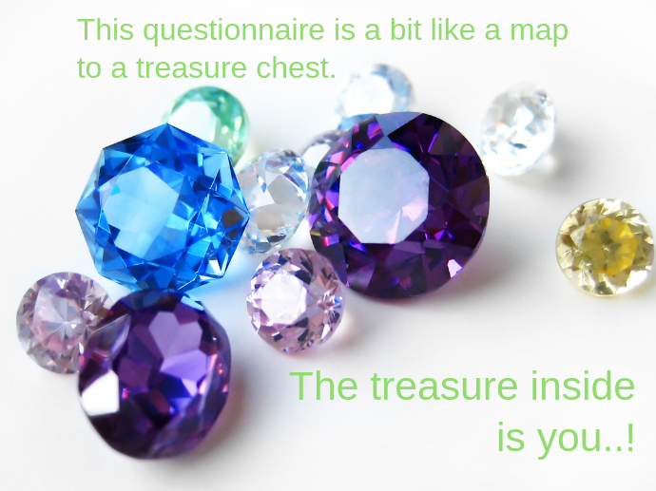

As you read the questions, let the answers emerge. Listen to
yourself and let your inner guidance take you deeper into the treasure chest…into your heart, where your soul based wisdom arises. You don’t need to answer each question if it doesn’t
feel relevant or valuable to you.* Let yourself be drawn to
what will benefit you the most through writing
about it and sharing it with me.
* A warm-hearted reminder to make this easy for yourself.
Just respond to the questions that you feel
will help you get the most from our work together.

Questions all about you…
- If there was a parallel universe with another version of you who was ‘living your dream’…the most wonderful life you could imagine – what would their life be like?

- If you had 3 wishes, what would you wish for?

- What makes you laugh? What helps you relax? What inspires you? What do you do in your life just for the sheer pleasure of it?

- What does the phrase ‘living from the heart’ mean to you?

- Are you aware of the gifts and challenges of your ‘shadow self’? What do you know of these and have you done any work to integrate them in the past?

- What have been the high points of your life? Your greatest successes? Your most powerful moments of connection and peace where life made sense? The times when you truly felt you could celebrate being you?

- What have been the low points in your life which you feel have impacted you the most? (If this question triggers something painful or an emotional wound from the past or present…wrap yourself in caring tenderness and only share as much as you feel comfortable with. A brief outline here is good for now. If it is appropriate we can take this into a very powerful healing space in our work together.)

- What is holding you back from living your dreams? Where do you feel stuck, spinning your wheels or are avoiding moving forward? (Apply the same caring tenderness I mentioned above - if this brings up anything particularly painful.)

Questions all about our work together…
- How would you like to be feeling at the end of the 3 month programme? What would you like to be happening in your life? What changes would need to happen for you to be experiencing that by the end of our work together?

- Have you had any previous experience of connecting with your heart power and the guidance, healing, inspiration and empowerment it offers you?

- What is your previous experience of Coaching and/or Therapeutic Support if any?

- With an Intake Questionnaire such as this, some coaching modalities ask…’How do you like to be held accountable?’ I don’t ask this question directly. My approach is more about getting alongside you – and supporting you to access the power of your heart which, when you are fully engaged with it, will carry you forward. This therefore dissolves the need to push yourself or to be driven by being held accountable. Are you happy with this? Would you prefer to also have some element of accountability?

- Are you comfortable with me expressing something that I sense is going on for you at a deeper level that you might not be aware of? To bring light to any possible blind spots?

- How do you best absorb information and express yourself? Through images, words, physical sensations or a combination of them all?

- How ready are you for change? Do you feel cautious or fearful of change and transformation? Or do you welcome it, feeling willing to go through whatever process is needed for you to fulfil your potential? Do you need very gentle support right now or a more dynamic deep dive into what your heart and soul knows is possible for you?

- Is there anything else that you want me to know about, take into consideration or incorporate in our work together?

